Global Core and Periphery

The core-periphery theory distinguishes between the core (developed), semi-periphery (NICs) and periphery countries (developing countries)
This correlates with the general distinction between the developed “North” and the developing “South” in the “North-South divide” in the Brandt Report (1980).
Core= Developed countries with high employment in tertiary sector.
Semi-periphery= Emerging countries that have developing rapidly recently.
Periphery= Usually exploited by the core for their natural resources.

World-Systems Theory
Criticized earlier theories which led to a breakthrough of other world system theories. According to Wallerstein the globalisation of the modern world brought global interdependence. It skewed in favour of the core as they needed the periphery countries’ natural resources.
Criticisms of his approach include:
- Too high levels of euro-centricity by underrating the sophistication of other early trading systems
- Very simple assumptions about the universal one-way flow of resources from the periphery to the core
- A failure to recognise the high level of competition between core nations

Clark-Fisher Model
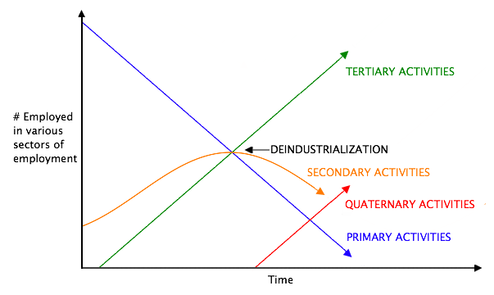
It shows the change in the level of employment of a country over time.
In the beginning, most people are employed in agriculture and other primary activities.
The secondary grows when the country becomes industrialised.
Primary and secondary jobs are widely replaced by machinery.
Secondary went down because of machines (took over the jobs of the workers) and the industrialised countries moved their factories to developing countries (cheaper!) (New international division of labour). Also because the MEDCs can import more of what they need. Stiff competition from countries with lower salaries.
Tertiary increased because people were more educated and wanted to work in the tertiary sector. People now earned more money and were therefore able to demand services.
Left side of diagram represents the Periphery, the middle part represents the Semi-Periphery, and the right side represents the Core countries (MEDCs have gone through the stages earlier).
Globalisation has been a significant factor in the changing importance of the sectors of employment in many countries.
The least developed countries still rely heavily on employment in the primary sector the disadvantage of this is that the prices of raw materials are low and fluctuate (which makes planning difficult), but do not rise as much as the prices on secondary commodities. This leaves the LEDCs with trade deficits (they have to pay for the more expensive manufactured goods with what they have earned on selling their primary commodities).

Identifying Core Nations
Examples: USA, Canada, EFTA, Japan, Australia, EU, NZ, Japan and Switzerland
Questionable whether they are Core or Semi-Periphery:
- First wave of NICS (South Korea, Singapore, Hong Kong, Taiwan)
- Oil-Rich Arab states
- Israel
Sure Semi-Periphery: NICs.
Periphery: The rest.
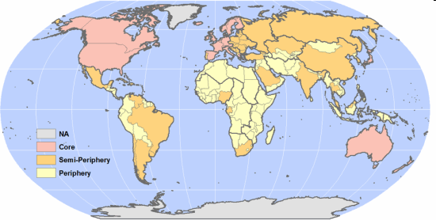

Global Economic Triangle of the CORE
North America
Western Europe
East Asia

High Income Countries
Main trade flows are between these areas.
Countries in this core have diversified economies, with high output, high purchasing power and large domestic markets.

Outside this core, the global periphery is a location of cheap raw materials or cheap manufacturing or a market for the core to “dump” their surplus products.

Wide range of countries SEMI-PERIPHERY
First waves of NICs – South Korea, Taiwan, Hong Kong, Singapore
Second wave of NICs or RICs – eg Malaysia, Mexico, South Africa
BRICs – Brazil, Russia, India, China
Resource exporting countries, Recently and Newly Industrialised Countries, Former Socialist Countries, Poorer European Countries.

Some of these countries could now be seen as part of the CORE (South Korea) others are characterised by regional disparities and social polarisation (Brazil) others with very rapid economic growth (Slovakia, China).

The excluded PERIPHERY
Lower Middle Income Countries and Low Income Countries.

Mainly Africa.
Small domestic markets, lack of infrastructure, population increase, low economic output, low levels of economic diversification, high agricultural population.

https://sites.google.com/site/ecumeneiboptionsandhigherlevel/higher-level-extension---global-interacttions/measuring-global-interactions/powerpoints

