THREE. PATTERNS IN ENVIRONMENTAL QUALITY AND SUSTAINABILITY
- Describe the functioning of the atmospheric system in terms of the energy balance between solar and long-wave radiation. Explain the changes in this balance due to external forcings (changes in solar radiation, changes in the albedo of the atmosphere and changes in the long wave radiation returned to space). Discuss the causes and environmental consequences of global climate change.
Definition of solar radiation:
Definition of long-wave radiation:

Energy budget = minus

Changes in the balance are due to external forcings
Forcing | Definition | How it increases or decreases it
Solar radiation
Albedo

Long wave radiation

Global climate change (make sure these are IB level and not basic):
Causes Consequences (think pol,env, ec, soc)
- -

- -

- -

- -
- -
-
-
-

- Explain the causes of soil degradation and discuss the environmental and socio-economic consequences and soil degradation management strategies.
Definition of soil degradation:
Why soil is important:-
-
-
Causes of degradation | Environmental consequences | Socio-economic consequences | Management strategy

- Identify the ways in which water is utilised at the regional scale. Examine the environmental and human factors affecting patterns and trends in physical water scarcity and economic water scarcity. Examine the factors affecting access to safe drinking water.
Definition of water scarcity:
Definition of water stress:

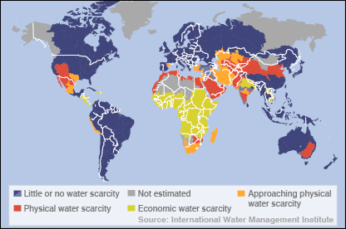
Describe the global pattern
of water

Main uses of water and % in LEDCs:

Main uses of water and % in MEDCs:

Factors affecting physical and economic water scarcity
Physical Human
- -

- -

- -

- -
-

Factors affecting access to safe drinking water:
Human Physical
- -

- -

- -

- -

Case study: China
China facts | Causes of decline | Consequences

- Explain the concept and importance of biodiversity in TRF. Examine the causes and consequences of reduced biodiversity.
Definition of biodiversity:

Why important? | Causes of decline | Consequences of decline
-

-

-

- Define the concept of environmental sustainability. Evaluate a management strategy at a local or national scale designed to achieve environmental sustainability
Definition of environmental sustainability:

Case study:
Facts:

Successes | Failures

FOUR. PATTERNS IN RESOURCE CONSUMPTION
- Evaluate the ecological footprint as a measure of the relationship between population size and resource consumption. Identify international variations in its size.
Definition of ecological footprint:

Definition of resource consumption:

Definition of bio-capacity:
Two factors that affect bio-capacity are and

Reasons for ecological footprint changing
Increasing Decreasing
- -

- -

- -

Ecological footprint of USA:
Ecological footprint of Malawi:

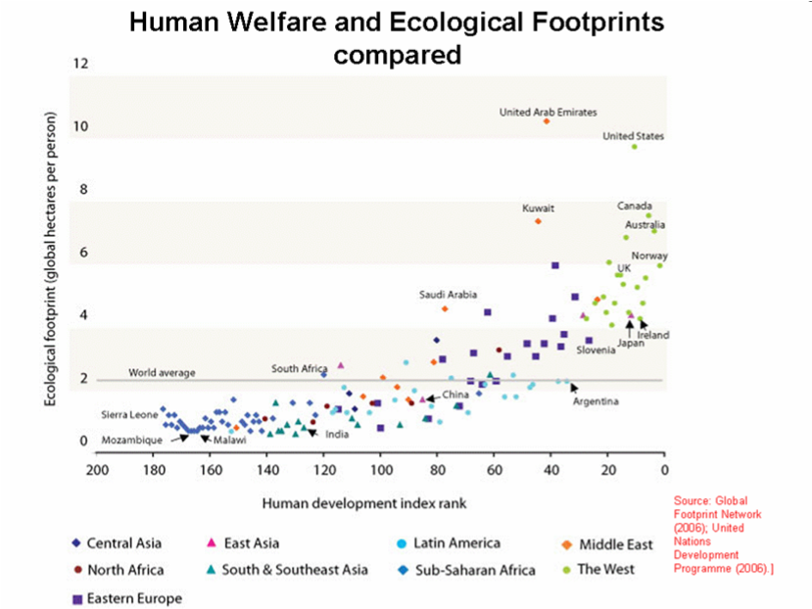
Describe and explain the pattern of
HDI and ecological footprint:

Argentina is close to the ‘ideal’.
How has it managed this?

- Discuss the neo-Malthusian view and anti-Malthusian view between population size and resource consumption.
 | Neo-Malthusian | Anti-Malthusian
Graph

Theory

Limitations

Famous geographers

- Examine the global patterns and trends in the production and consumption of oil.
Describe and explain the pattern of
oil production

Describe and explain the pattern of
oil consumption

- Examine the geopolitical impacts and environmental impacts of these changes in patterns and trends.
Geopolitical impacts Environmental impacts
Kuwait? Oil spills?

Crimea? CO2?

Nigerian militant groups? Acid rain?

- Examine the changing importance of other energy sources.

Definition of sustainable development:

 | % use in the world and where | Advantages | Disadvantages
Solar
Wind
Hydro
Geo-thermal

- Discuss the reduction of resource consumption by conservation, waste reduction, recycling and substitution. (see geofile 548)
 | Conservation | Waste reduction | Recycling | Substitution
Definition
Example | -  - | -  - | -  - | -  -
Has it been successful?

- Evaluate a strategy at a local or national scale aimed at reducing the consumption of one resource.

Named place: Three Gorges Dam, to produce HEP Geofactsheet 114

Resource conserving

Why it is needed

Strategy outline

Benefits of strategy (social/economic)

Disadvantages of strategy (social/economic)

