FH-011 - International organizations

Food insecurity
What is food insecurity?
?????
Brainstorm and then list 5 ways in which food insecurity can be addressed in low income countries?
?????
How big of an issue is food insecurity in high income countries?
?????

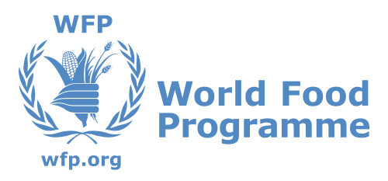

What does the World Food Programme do to combat food insecurity?
Search Google News for the most recent article to mention action taken by the World Food Programme. Outline the actions taken in your notes. Page 73
?????
Who is the World Food Programme and what do they aim to do?
?????
How is the World Food Programme funded?
?????

What does the Food and Agriculture Organization do to combat food insecurity?
Search Google News for the most recent article to mention action taken by the Food and Agriculture Organization. Outline the actions taken in your notes. Page 72.
?????
Who is the Food and Agriculture Organization and what do they aim to do?
?????
How is the Food and Agriculture Organization funded?
?????

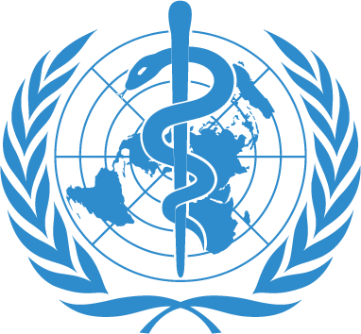

What does the World Health Organization do to combat disease?
Search Google News for the most recent article to mention action taken by the World Health Organization to combat a disease that you have studied. Outline the actions taken in your notes. Page 74
?????
Who is the World Health Organization and what do they aim to do?
?????
How is the World Health Organization funded?
?????

What does the Trussell Trust do to combat food insecurity?
How ‘big’ is the situation that the Trussell Trust is dealing with?
?????
What does the Trussell Trust do?
?????
State three ‘factoids’ about Trussell Trust and the actions they take to combat food insecurity.
?????

What does NothingButNets do to combat malaria?
What is different about the approach taken by NothingButNets?
?????
Why not just send your money to the WHO and their malaria projects?
?????
What does NothingButNets do?
?????
State three ‘factoids’ about NothingButNets and the actions they take to combat malaria.
?????

What do governments do to combat disease and food insecurity?
From the notes you have already made - how have governments been involved?
?????
Search Google News for a incidence of when a government of your choice has taken action to combat food insecurity in their own country. Outline the example. Norwegian farming subsidies (please click on the link).
?????
Search Google News for a incidence of when a government of your choice has taken action to combat food insecurity in another country and they have a connection with. Outline the example. Yemen
?????
Search Google News for a incidence of when a government of your choice has taken action to combat a disease in their own country. Outline the example. Corona
?????
Search Google News for a incidence of when a government of your choice has taken action to combat a disease in another country and they have a connection with. Outline the example. Norwegian aid against diseases
?????

